ASSIGNMENT 1
DOCUMENTATION

ISTE 140 - Web and Mobile I
Fall 2026

Team 5

LearnWare Project

Team Information

Member | Name | ID | Contribution
1 | Ritika Lakhotia | 431006114 | Branding, Documentation & Validation
2 | Roman Martianov | 748002846 | CSS and Technical
3 | Danil Nazin | 748007523 | HTML

Team Number: 5
Tutorial Topic: Cybersecurity / Malware
Contribution statement: We confirm that the contributions listed above accurately describe each member’s work on Homework 1 and that each member can explain the submitted work.

2. Branding
Site name: LearnWare
Tagline: Think Before you click

2.1 Why we chose the site name

2.2 Initial logo sketches

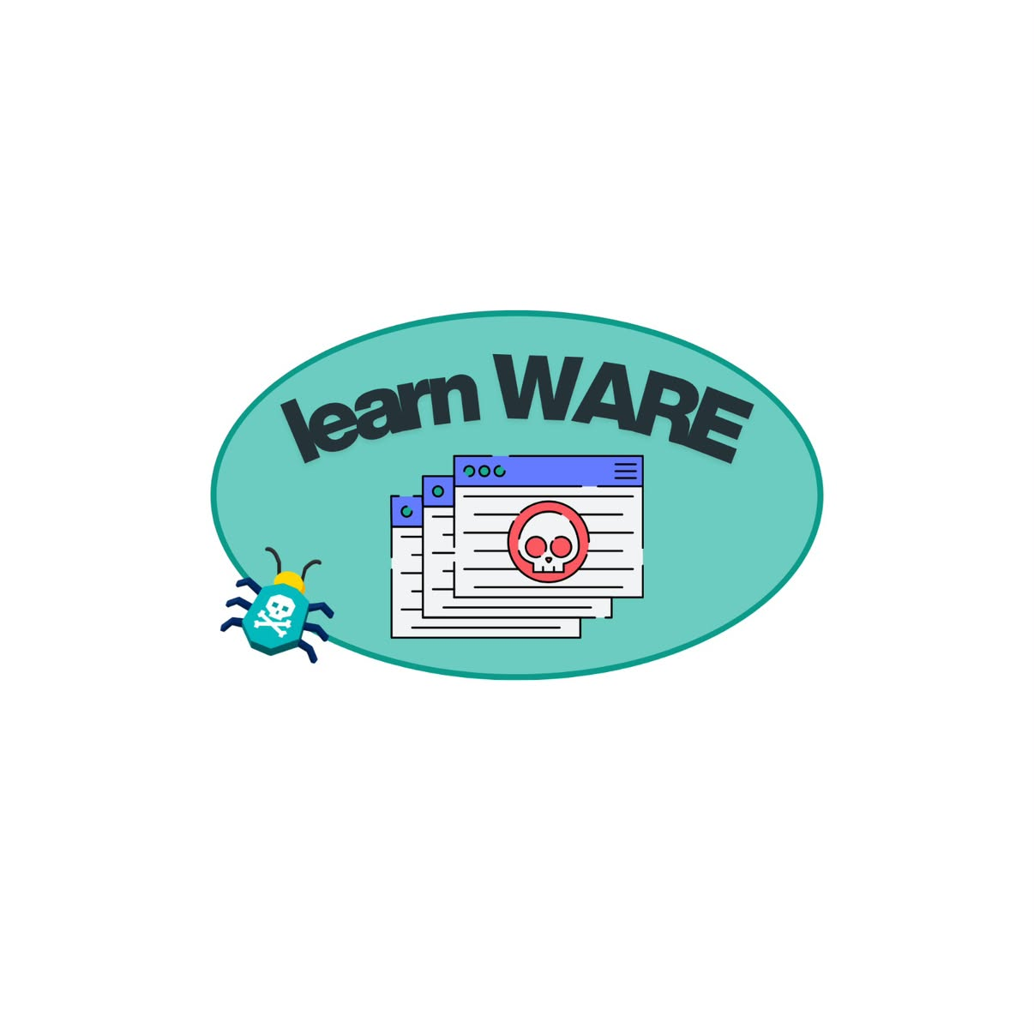

2.3 Final Logo and exlanation
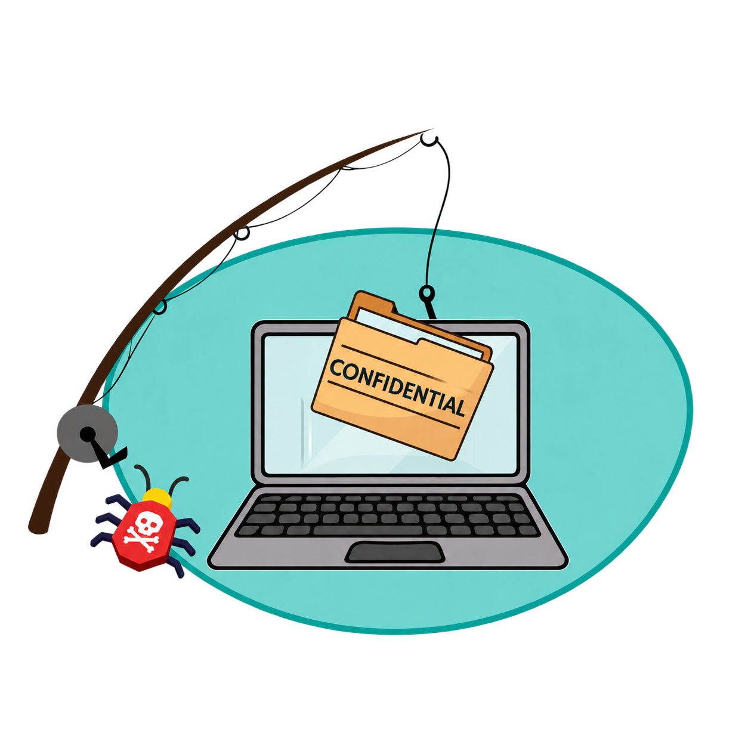

The logo shows a laptop with a "CONFIDENTIAL" folder being pulled out by a hook. The hook represents phishing, the bug represents malware, and the folder represents the private data attackers try to steal. It visually summarizes the site’s topic: hidden online threats trying to steal your data.

3. Q1 - UNIX and Terminal (Individual)

3.1 Ritika Lakhotia
Student ID: 431006114

    - Project folder tree

    - Mv/ rm / cp operations

    - Permissions

    - Answers

3.2 Roman Martianov
Student ID: 748002846

    - Project folder tree
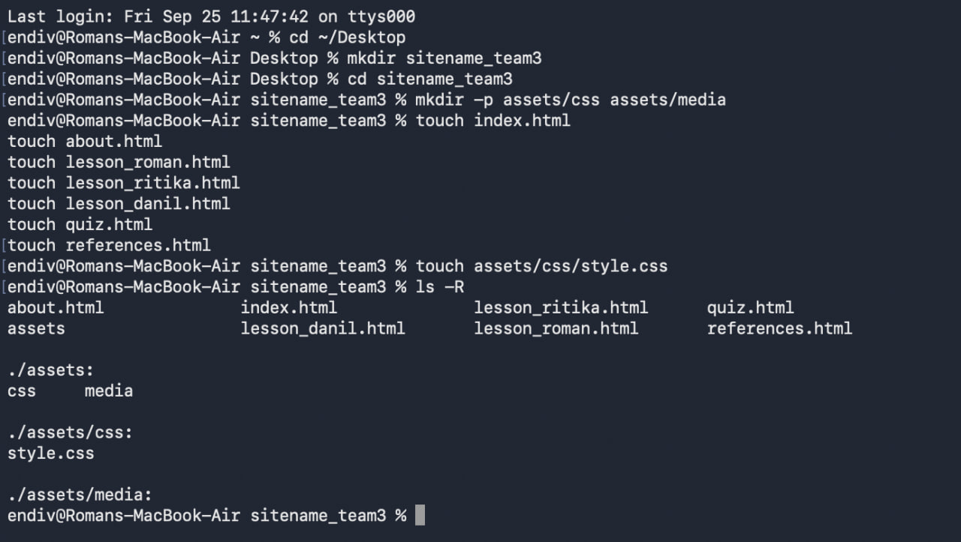

    - Mv/ rm / cp operations
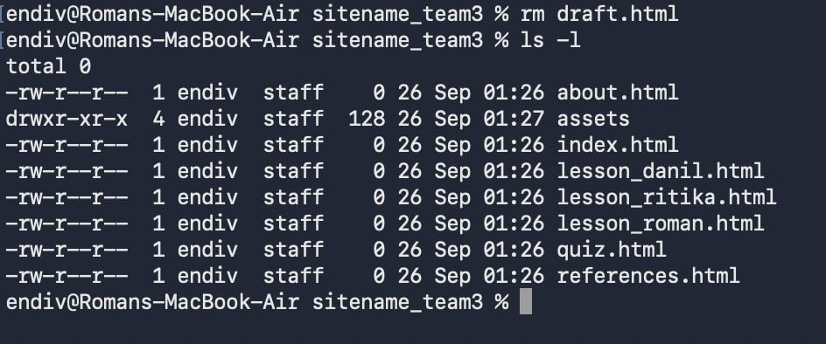
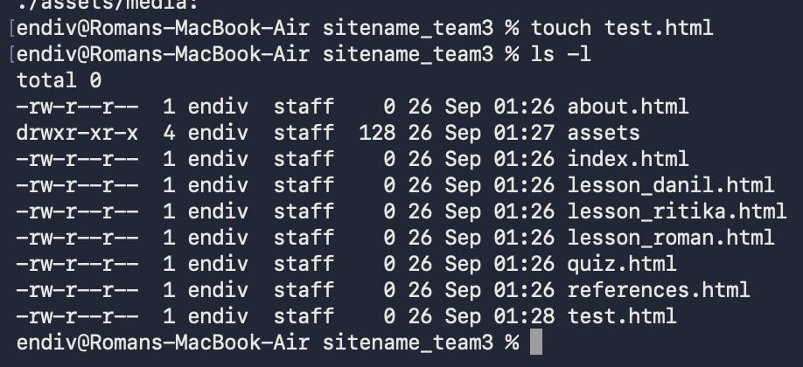
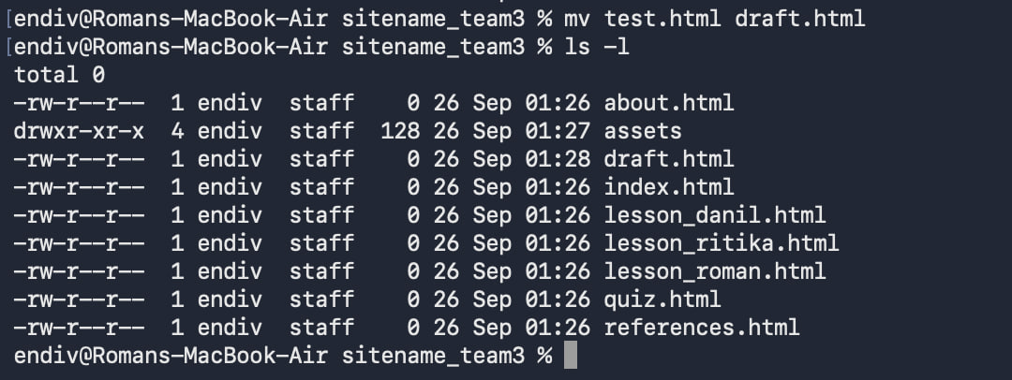
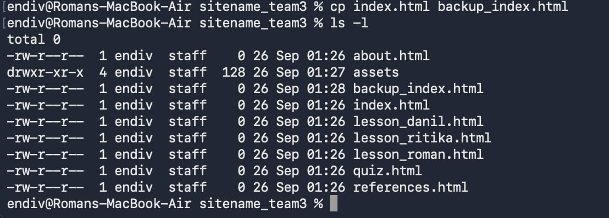
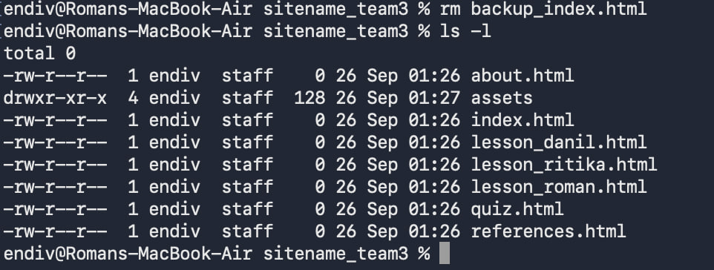

    - Permissions

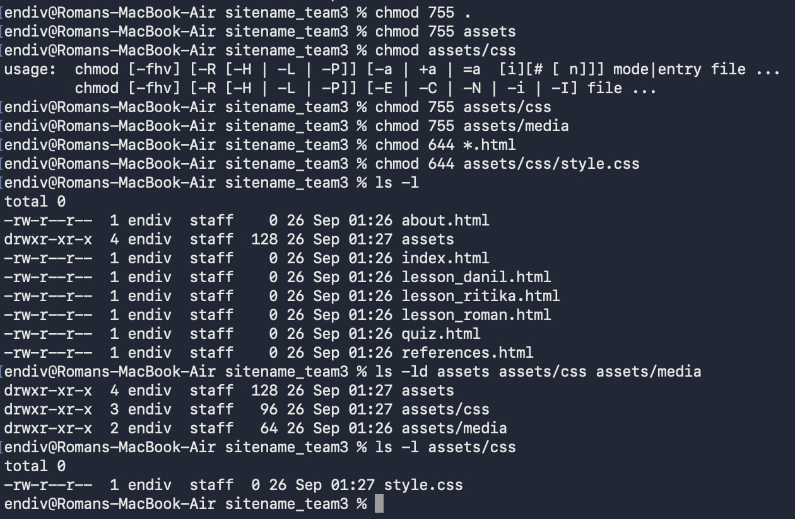
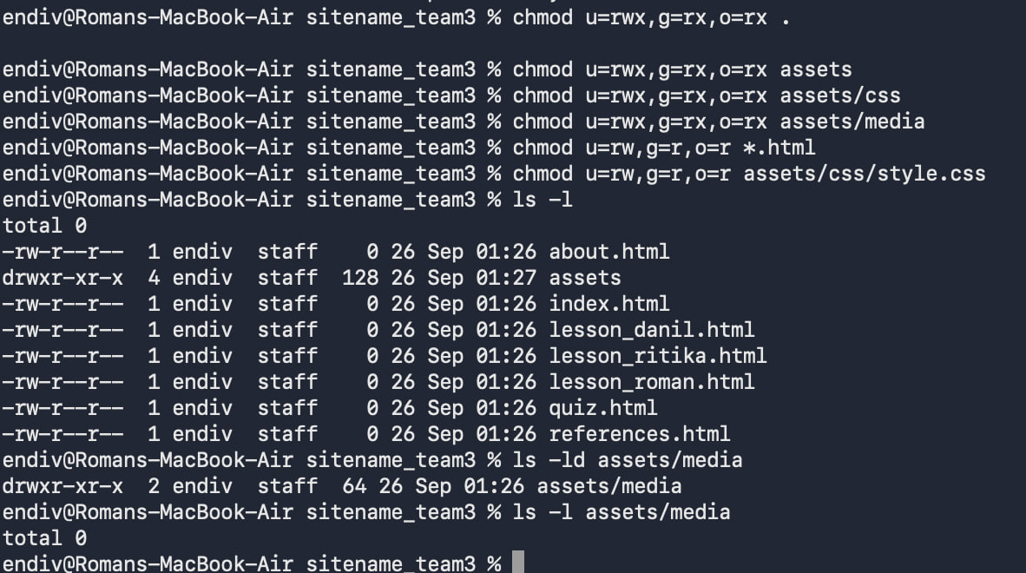

    - Answers

1. The relative paths would be `../media/logo.png` and `assets/css/style.css`. The absolute path would be `/home/username/public_html/LearnWare_team5/assets/css/style.css`.
2. `755` permits the owner full read/write/execute privileges and group/others read and execute privileges. `644` permits the owner full read and write privileges and everyone else read only. HTML files should not have the execute permission set since the browser just needs to read the file.
3. The command is `chmod quiz.html 640`. Given these permission settings, the page will not be readable by typical website visitors, so read permission must be set.

3.3 Danil Nazin
Student ID: 748007523

    - Project folder tree

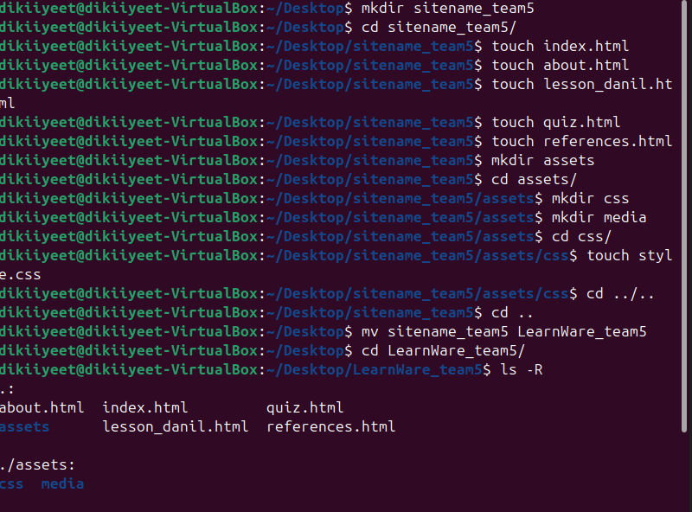

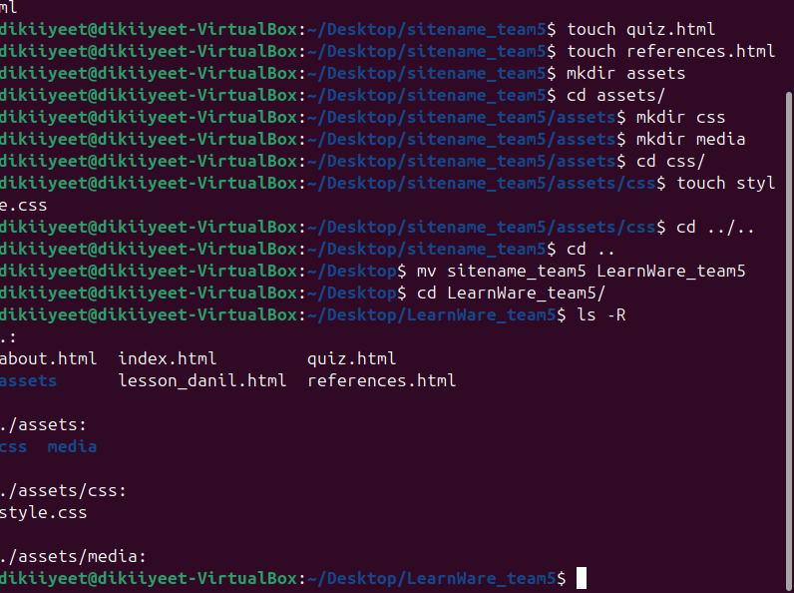
    - Mv/ rm / cp operations

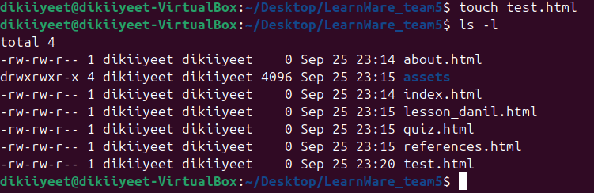

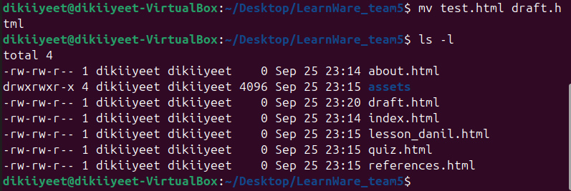
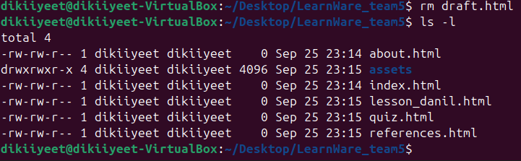
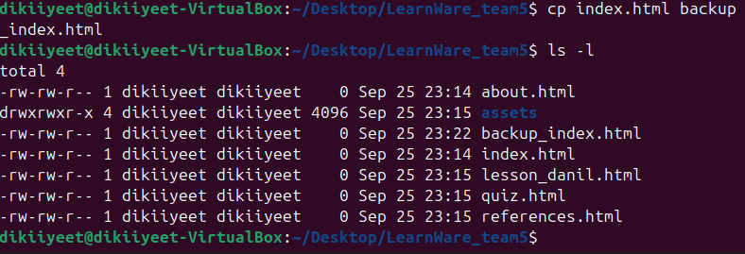
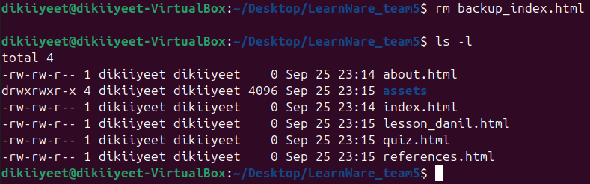
    - Permissions

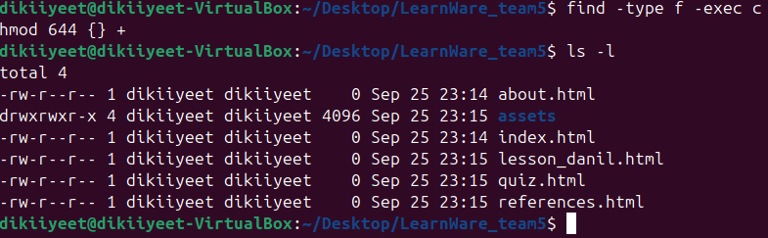
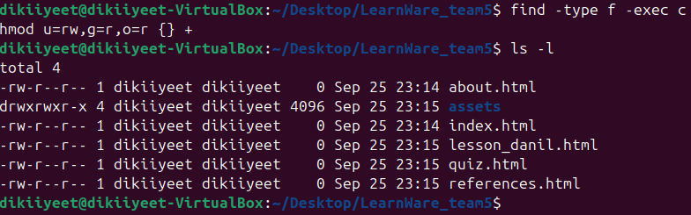
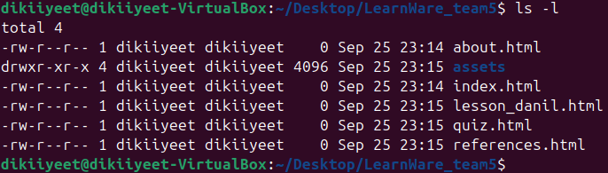
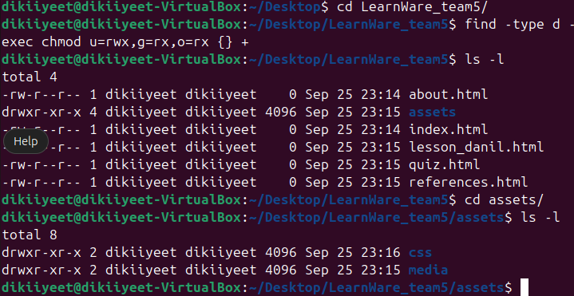
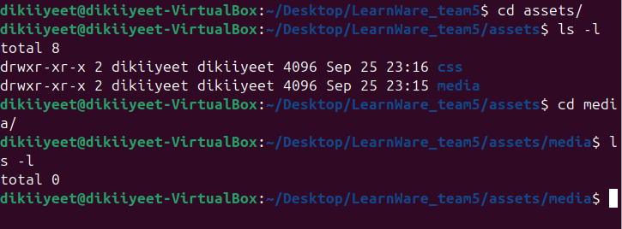

    - Answers

1. Relative path is ../media/logo.png. Second relative path is assets/css/style.css. Absolute path is /home/username/public_html/LearnWare_team5/assets/css/style.css
2. 755 for chmod means that for directories, user has permission to read, write and execute, and group and world can only read and execute. 644 for chmod means that for files, user had permission to read and write, and group and world can only read. HTML files should not be executable because they could contain malware that is bypassing through browser. As HTML is not considered a programming language, they can carry obfuscated malware which is easy to create and hard to spot.
3. chmod quiz.html 640 is the command. If I would do that, visitor of my website will not be able to see the page, because the permission to see that page is denied, that is why "Read" permission should always be open.

4. Mac Workflow

4.1 Ritika

4.2 Roman

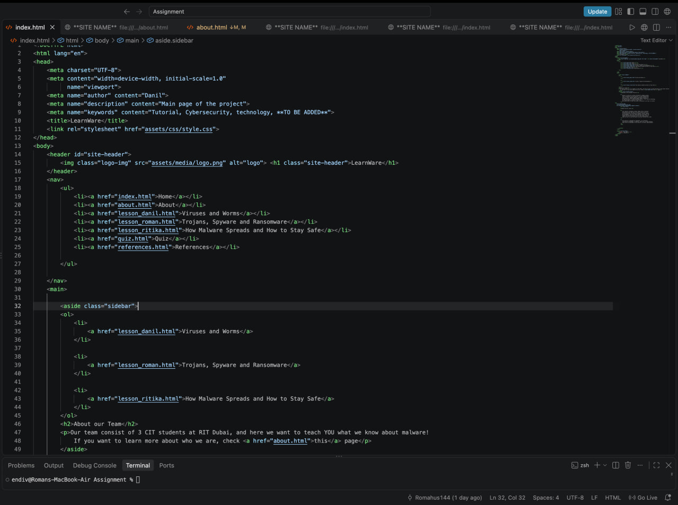

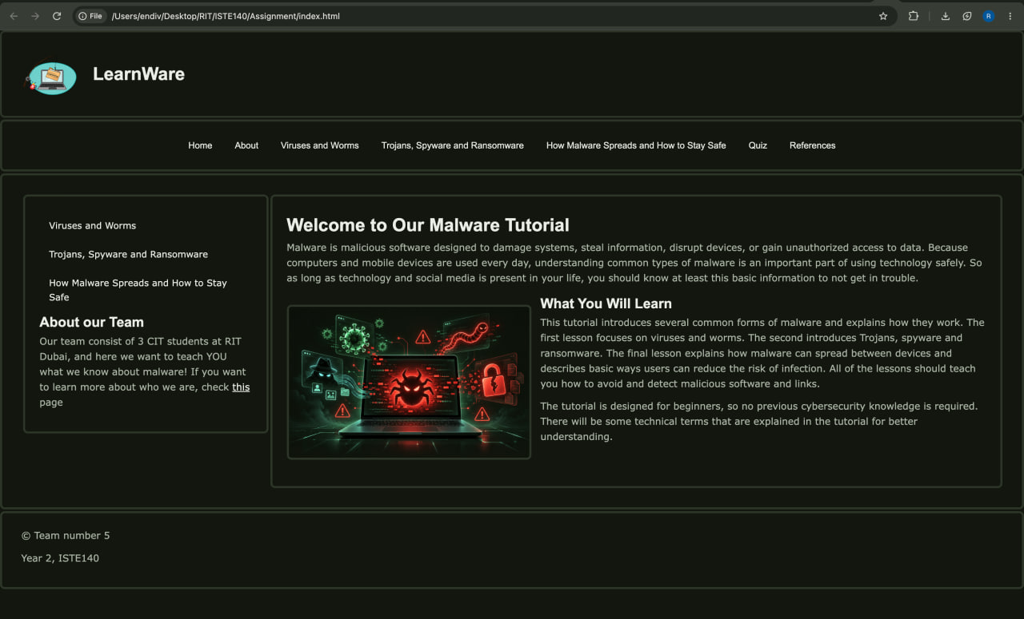

4.3 Danil
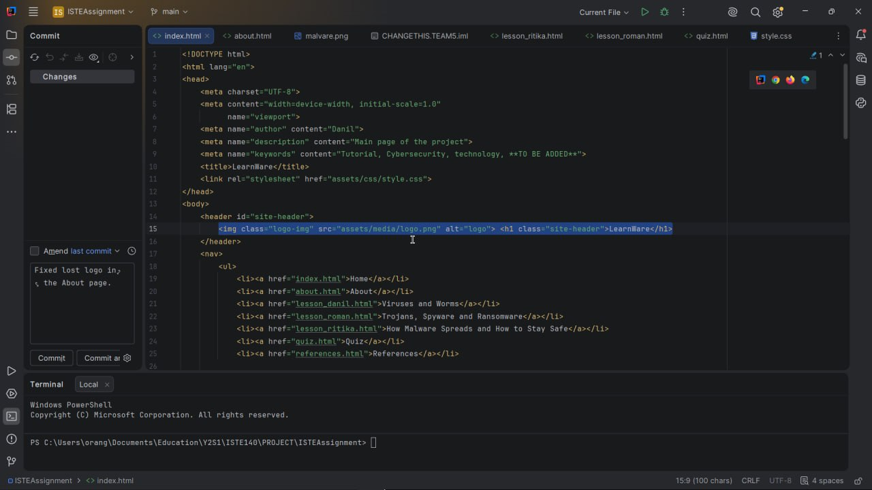
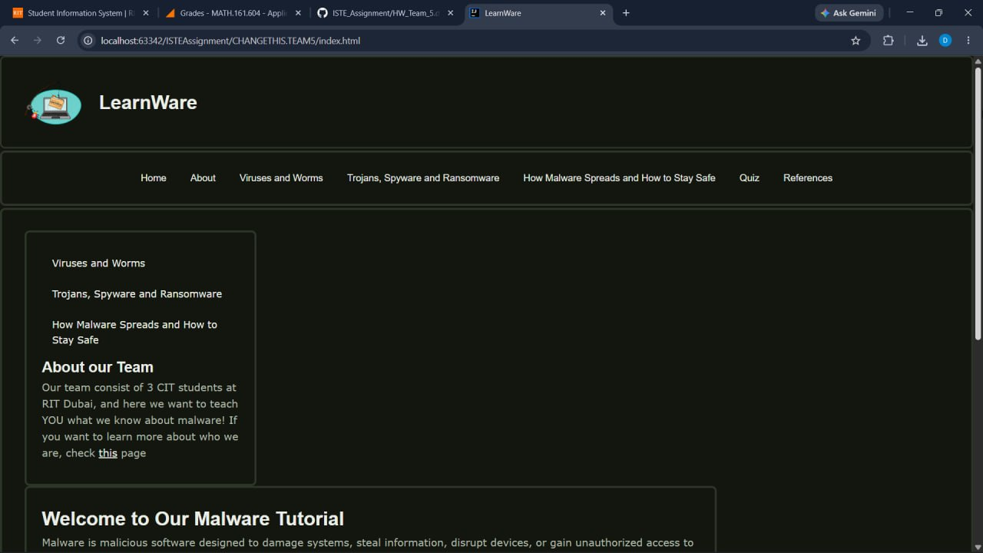

5. FileZilla Deployment

5.1 Connection Settings

Host: banjo.rit.edu
Port: 22
Username: rm6697

5.2 Remote folder tree

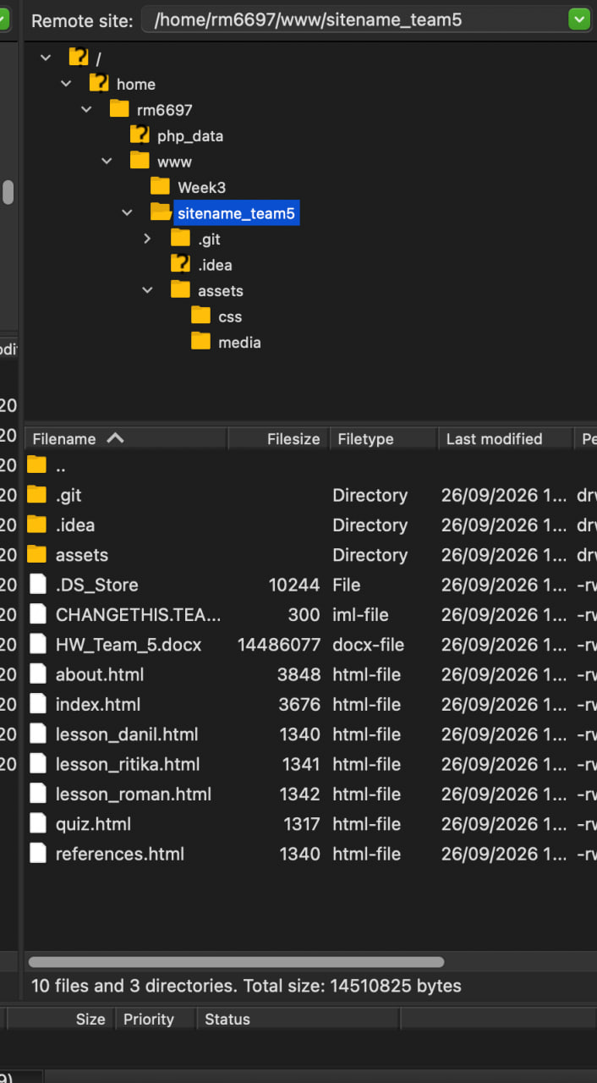

5.3 assets/media permissions

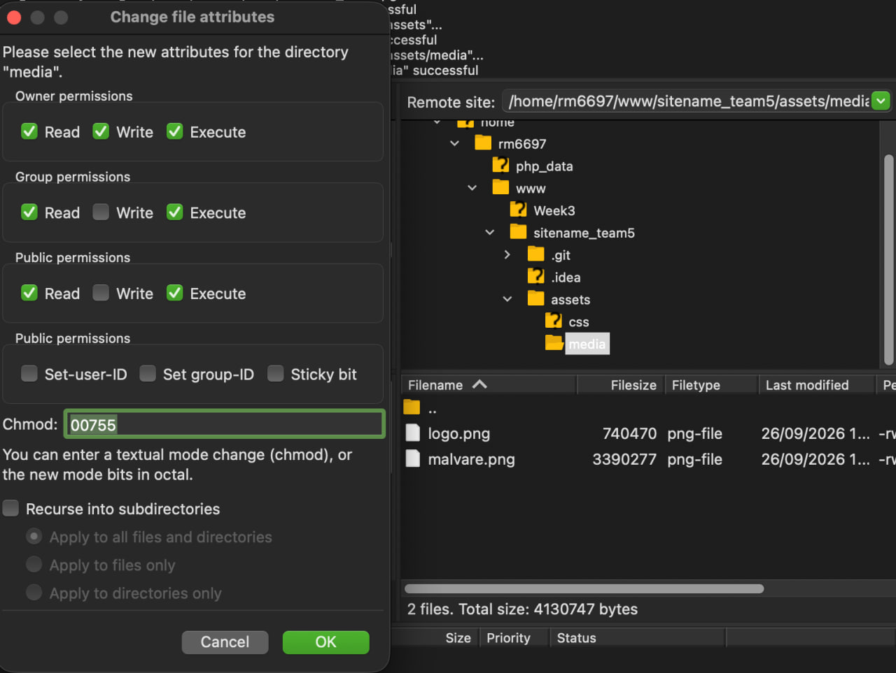

6. Live URLPublished Site

6.1 Live URL

https://people.rit.edu/rm6697/sitename_team5/index.html

6.2 Published-site screenshot

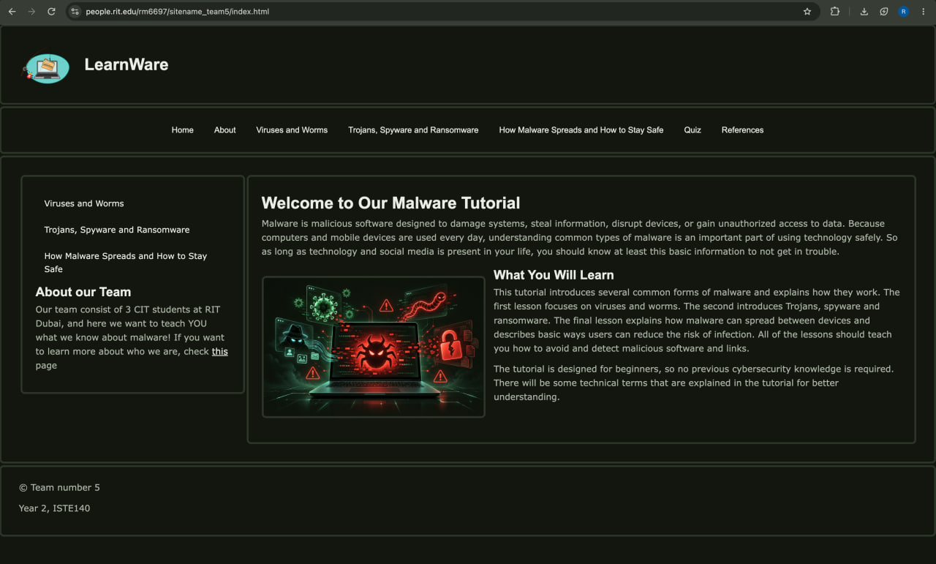

6.3 banjp.rit.edu vs people.rit.edu

banjo.rit.edu is the server where we upload files via SFTP (using the FileZilla program).

people.rit.edu is the address where the website can already be opened in a browser (e.g., http://people.rit.edu/username).

7. Validation

7.1 index.html - W3C HTML Validator

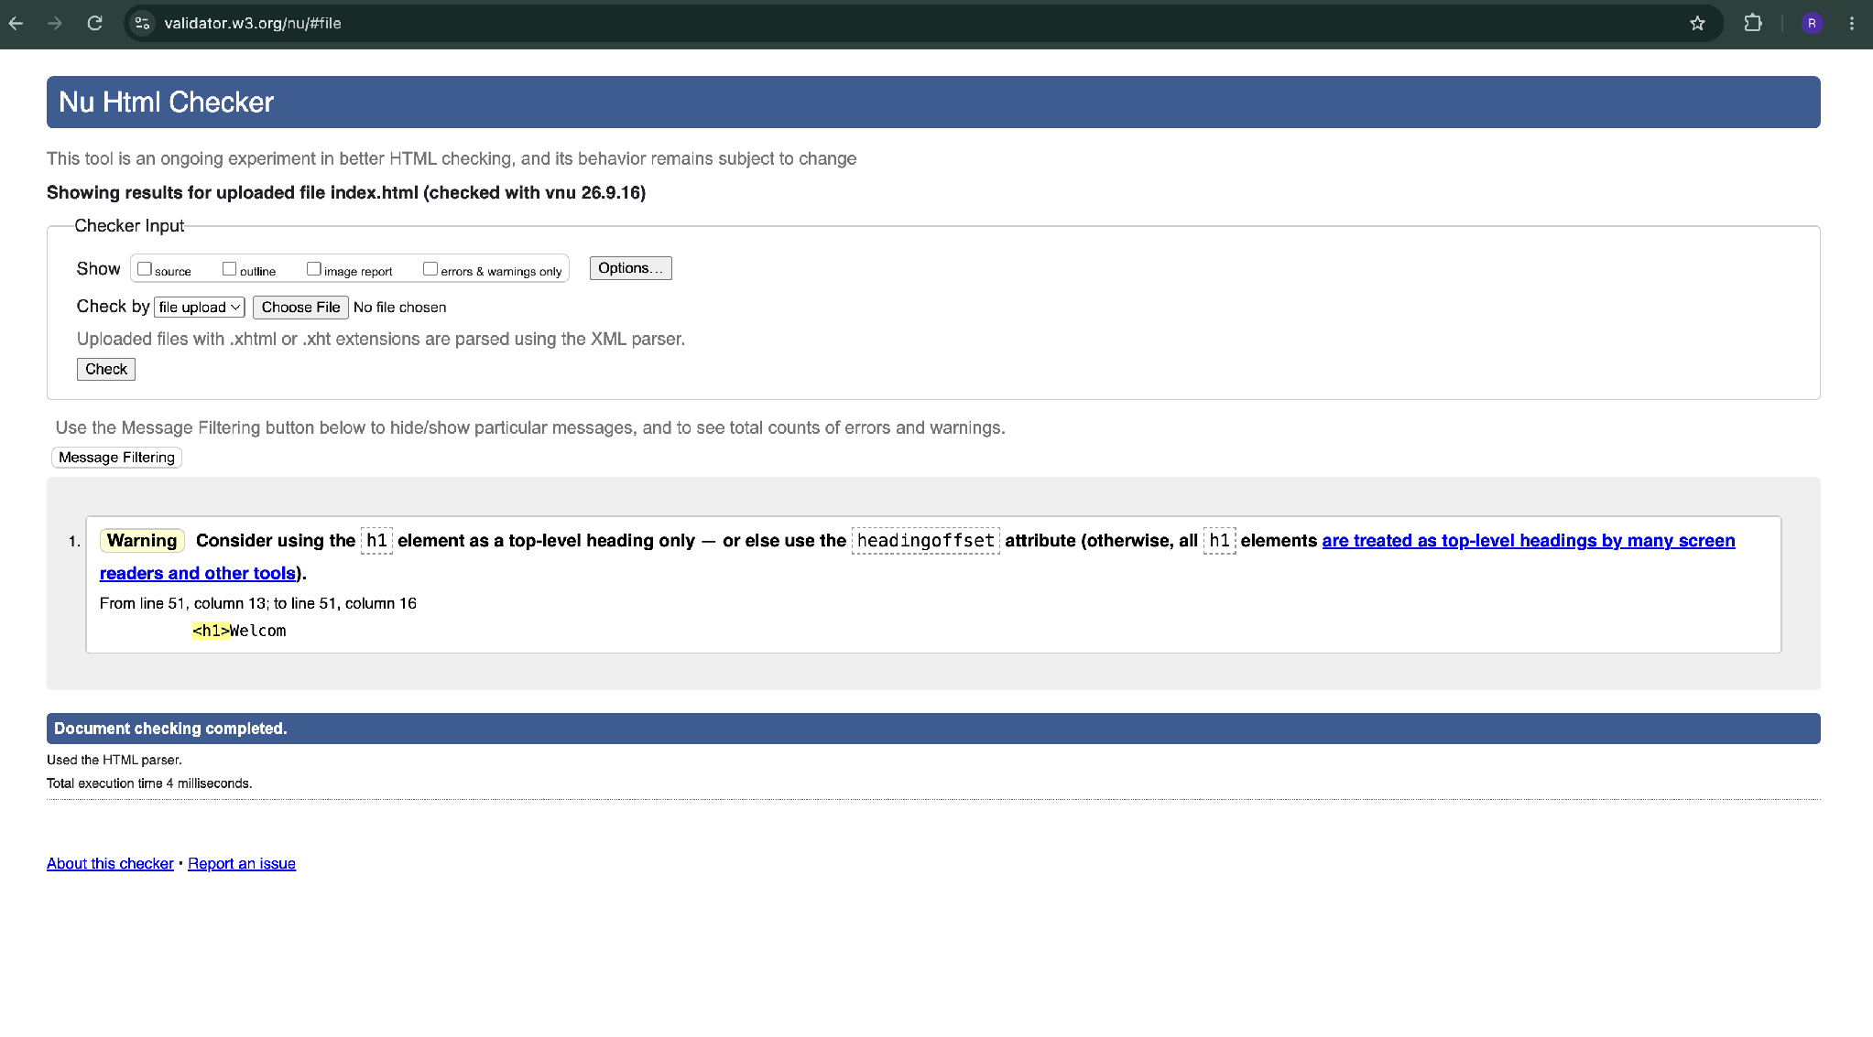
7.2 about.html - W3C HTML Validator

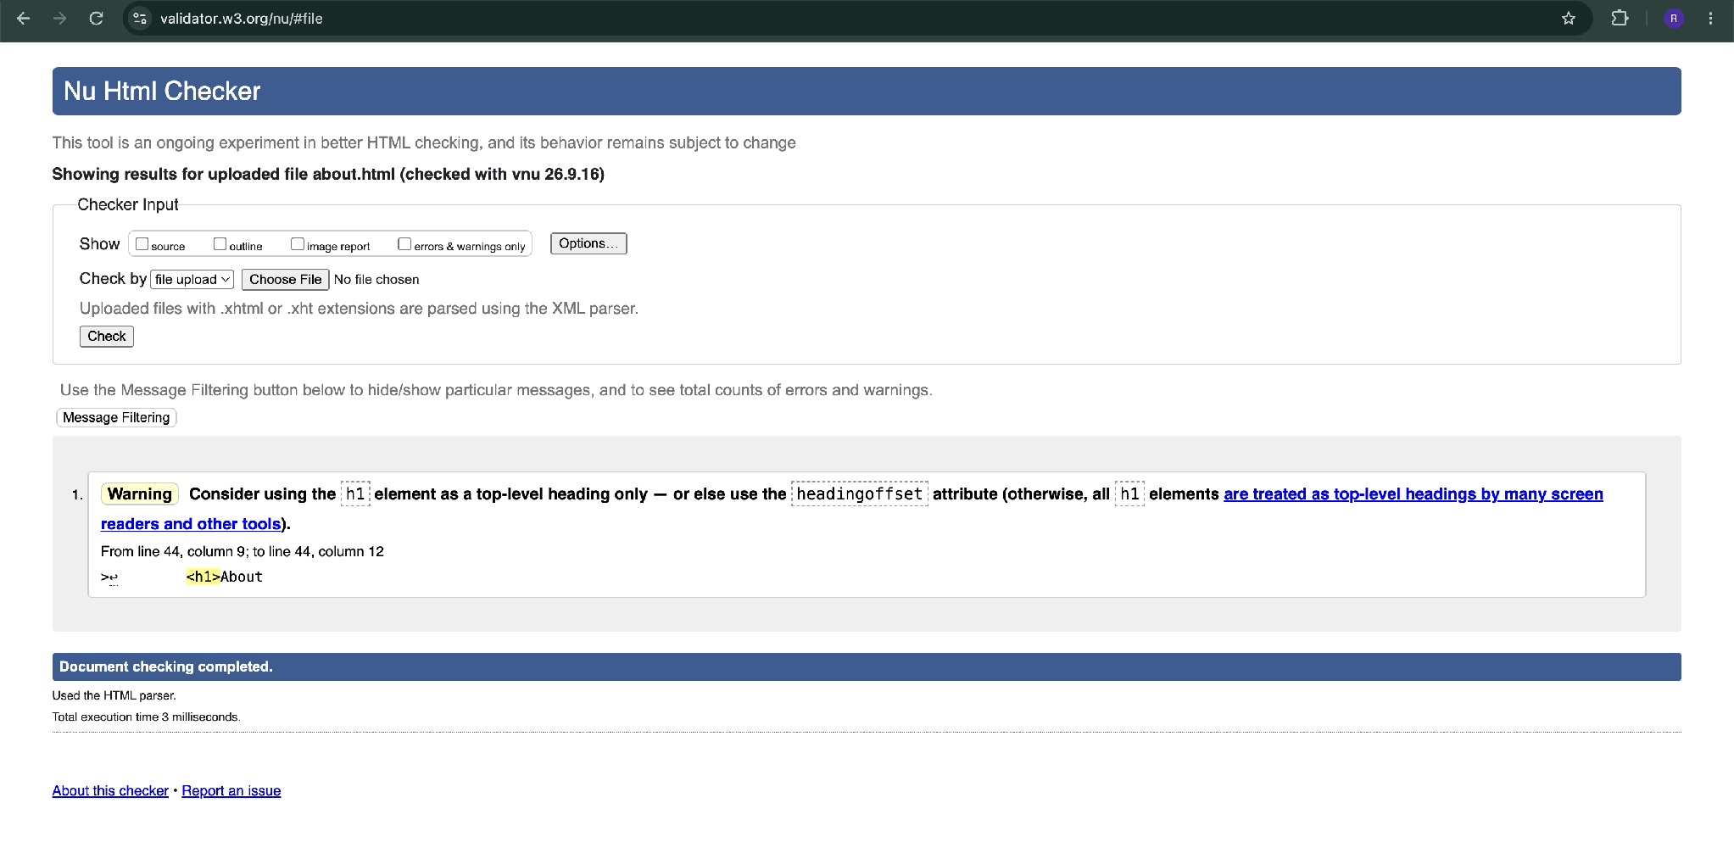

7.3 style.css - W3C CSS Validator
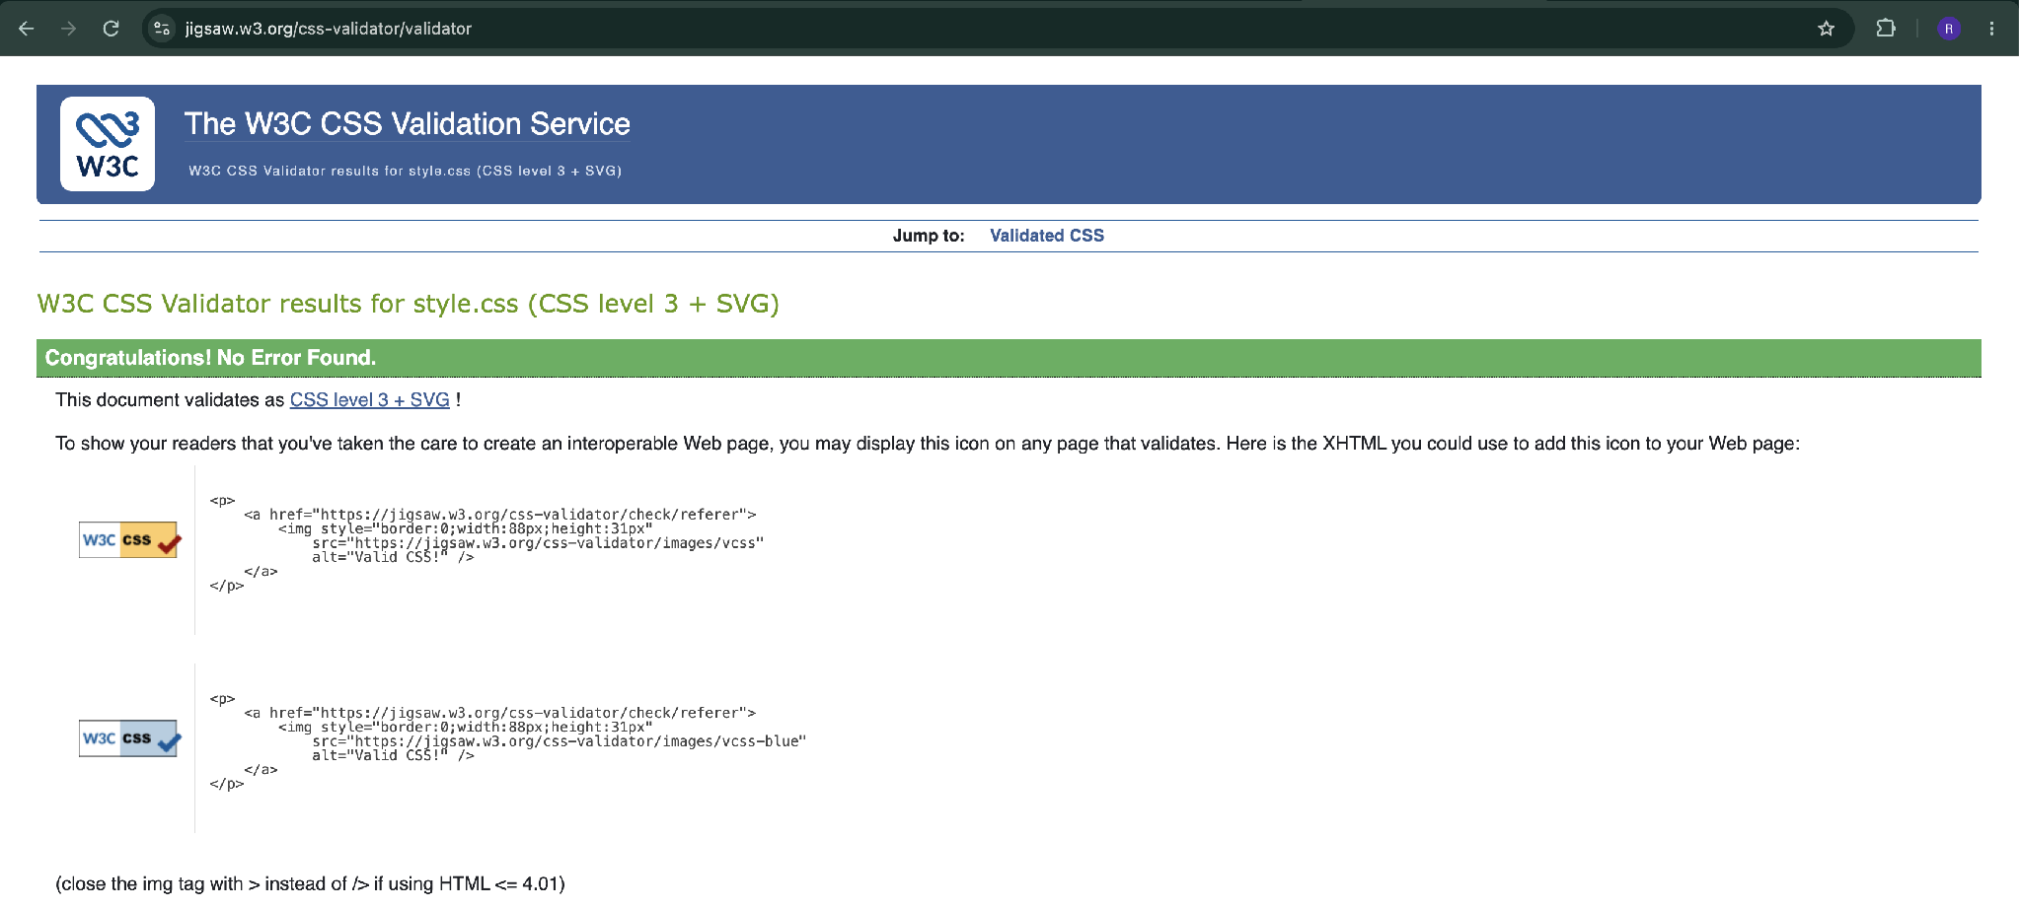

8. Validation Errors Encountered and Fixes

Error | Fix | Why it fixed
index.html: Warning – <h1> should be used as a top-level heading only | Changed the content heading Welcome from <h1> to <h2> | The page already had a main <h1>, so the content heading should be lower-level
about.html: Warning – <h1> should be used as a top-level heading only | Changed the content heading About from <h1> to <h2>. | The page already had a main <h1>, so the content heading should be lower-level

